European Bank for Reconstruction and Development

SABAC RESIDENTIAL BUILDINGS - ENERGY EFFICIENCY PROJECT
  - Environmental & Social Management Plan (ESMP)

Type of Document (Version) Confidential

Project no. 70057331
Our Ref. No. REP-ENV 05

DATE: July 2019

WSP
8 First Street
Manchester
M15 4RP
Phone: +44 161 200 5000

WSP.com

Quality Control
Issue/revision | First issue | Revision 1 | Revision 2 | Revision 3
Remarks | First draft for comments | First draft comments responded
Date | 05/06/2019 | 02/07/2019
Prepared by | Joe Benson  Liz Watts  Konstantin Siderovski | Joe Benson  Liz Watts
Signature
Checked by | Neal Barker | Neal Barker
Signature
Authorised by | Neal Barker | Neal Barker
Signature
Project number | 70057331 | 70057331
Report number | REP-ENV 05 | REP-ENV 05
File reference | \\uk.wspgroup.com\central data\Projects\700573xx | \\uk.wspgroup.com\central data\Projects\700573xx

Contents

1 Introduction 1
1.1 Scope 1
1.2 Intended USers 2
2 SABAC RESIDENTIAL BUILDINGS - ENERGY EFFICIENCY PROJECT 3
2.1 Project Overview 3
2.2 Description of Project Environs 4
3 Organisational arrangements 6
3.1 Project influence 6
3.2 Management Structure and Resource Capacity 7
3.3 EHSS Management Meetings and Reports 8
4 Environmental and SOcial Management Plan 9
4.1 Contractor Requirements 9

Tables
Table 3-1 – Šabac Residential Buildings Energy Efficiency Project stakeholders 6
Table 4-1 – Contractor’s E&S actions for before and during construction for the Šabac Residential Buildings Energy Efficiency Project 11

Figures
Figure 2-1 - Satellite View A of Benska Bare, Šabac 4
Figure 2-2 - Satellite View B of Benska Bare, Šabac 5

Introduction
The District Heating Company (“Toplana-Šabac”) of the City of Šabac approached the European Bank for Reconstruction and Development (EBRD or the “Bank”) with the request to finance an energy efficiency improvement programme in the City. This programme is for the implementation of energy efficiency measures in 40 residential buildings (private apartments), including insulation measures and introduction of thermostatic valves and heat allocators. The 40 buildings have been provisionally selected, with some preliminary technical studies completed and a work program for each building available.
Situated on the right banks of the river Sava in western Serbia, Šabac is the economic and cultural centre of Mačva and Podrinje regions. In the City, District Heating (DH) is solely provided by “Toplana-Šabac” (the “DH company”), the public utility company for the production and distribution of thermal energy. Wholly owned by the City, the district heating in Šabac is one of the most advanced systems in Serbia.

Scope
This Environmental and Social Management Plan (ESMP) has been developed to avoid or mitigate potential temporary disruptions and nuisance caused by the project construction and implementation. It also provides information on the appropriate disclosure of information on the planned rehabilitation works to the affected persons.
This document outlines what environmental and social (E&S) mitigation measures must be followed during the construction phase of this project. After providing a brief overview of the project and its management structure, the document presents a table of E&S actions that will be the responsibility of the contractor(s) engaged on this project to address. The Contractor’s Construction Environmental and Social Management Plan (CESMP) will be based on this document.
Overall, the aims of this ESMP are to:
- Identify the key environmental and social issues or sensitivities related to the Project;
- Describe the mitigation measures and show how the effectiveness of the mitigation will be monitored;
- Ensure that the program will be developed and operated according to requirements EBRD and the EU;
- Ensure that the programme will comply with relevant Serbian environmental legislation and other corporate and Lender requirements throughout its construction phase;
- Identify roles and responsibilities for these actions; and
- Propose mechanisms for monitoring compliance.
The ESMP has been prepared to identify the environmental and social management and mitigation actions required to implement the Project with the requirements of EBRD’s Performance Requirements and applicable Serbian legislation. The ESMP sets out the management controls and measures required to mitigate the potential environmental and social impacts that were identified in the ESDD report through various designed plans, programmes, specifications and guidelines.
The potential impacts and associated mitigation measures and management procedures in this ESMP are based on the information and assessments identified in the due diligence carried out by the EBRD, and in line with the Environmental Social Action Plan (ESAP) prepared for the Project in 2019. This ESMP details the environmental and social management procedures and mitigation / monitoring measures required to complete actions identified in the ESAP.
In addition, for this project a Stakeholder Engagement Plan (SEP) has been prepared for Toplana-Šabac. The actions provided in this document will be organised by Toplana-Šabac, running alongside the Contractor’s management and monitoring tasks captured in this ESMP. Any action in the SEP which involves the contractor(s) are also mentioned in this ESMP.
Fully endorsed by Toplana-Sabac, the DH Company will ensure that the ESMP is implemented by the Contractors by integrating the ESMP in the tendering and contractual documents. The ESMP will ensure contractors adhere to and adopt good construction practices and environmental, health and safety and social standards in line with the Bank's PRs.

Intended USers
The aim of this document is to communicate to the Project Team (particularly contractors and potential sub-contractors), the potential environmental and social issues associated with the proposed scheme and the procedures and mitigation measures that are required to be implemented.
The Project Team will utilise this ESMP during project execution to achieve appropriate and effective environmental and social management.
Contact details for Toplana-Šabac are as follows:
Public Utility Company “Toplana-Šabac”, the Šabac District Heating Company
Name: Slobodan Jerotic, CEO
Address - Djure Jakšića 1, Šabac, Serbia
Telephone - +381(0)15342975
Email - slobodan.jerotic@sabac.org

SABAC RESIDENTIAL BUILDINGS - ENERGY EFFICIENCY PROJECT

Project Overview
District Heating (DH) in Šabac is solely provided by the Šabac DH company “Toplana-Šabac”, (the “DH company”) wholly owned by the City. The City approached EBRD with the request to finance an energy efficiency improvement programme in the City. This is for the implementation of energy efficiency measures in 40 multi-storey residential buildings (private apartments), including insulation measures and introduction of thermostatic valves and heat allocators.
The 40 buildings have already been selected with some preliminary technical studies completed and a work program for each building available. The selected buildings are all situated in and around the densely populated area of Benska Bara, located in the centre of Šabac. All selected buildings are connected to the central heating system.
The proposed set of the Energy Efficiency (EE) measures includes two groups of actions:
- Civil engineering measure - thermal insulation of buildings by cladding of exterior walls
The external wall insulation system comprises a layered non-load method that encases the building preventing the unnecessary loss of heat. Typically, the building is first wrapped in high quality expanded polystyrene (EPS) products / boards fixed on the wall surfaces. These products will be of proven quality, in accordance with the applicable technical regulations and standards in Serbia. Once the boards are placed, water-resistant finished surface will be applied to achieve the required aesthetic appearance. Also included in this measure, is the rehabilitation of existing water drainage on the buildings and hydro-insulation on the building roofs.
In addition to the benefits gain from the increased energy efficiency - savings between 50% and 55%, accompanied with the lesser consumption of fossil fuels and reduced emissions of greenhouse gases - it is expected that this measure would increase the properties’ value and improve the aesthetic value of the buildings and the district Benska Bara as a whole, making it more attractive in the real estate market. Finally, this measure is seen as an important incentive for the local economy.
- Control of heating systems in residential units
This group of EE measures includes introduction of thermostatic radiator valves and heat cost allocators in each residential unit.
  - Introduction of thermostatic radiator valves (TRVs)
Thermostatic valves will be fitted to the individual radiators in the apartments to automatically regulate and maintain the room temperature, by changing the flow of hot water to the radiator. The key benefit of thermostatic valves is their energy saving potential by avoiding overheating commonly caused by manual valves. The use of thermostatic valves will contribute to the reduction of energy consumption and the increase of the energy efficiency of the existing heating systems in the selected buildings.
  - Introduction of heat cost allocators
Electronic heat cost allocators will be attached on the individual radiators in the apartments to measure the individual heat consumption and enable it to be allocated to each household of the building. The heat consumption data will be transmitted via wireless technology to the Šabac District Heating Company’s billing system where a household bill will be generated for each apartment in the building, without any direct involvement of residents and property owners.

Description of Project Environs
The loan will be used by Toplana-Šabac to introduce energy efficiency measures in approximately 40 residential buildings in Šabac. More buildings could be introduced, depending on the exact pricing of the efficiency measures. The 40 buildings currently shortlisted are in the area of Benska Bare (also known as Benska Bara) – a predominately residential area close to the city centre.
Satellite imagery of the area is shown in the figures below:
Figure 2-1 - Satellite View A of Benska Bare, Šabac
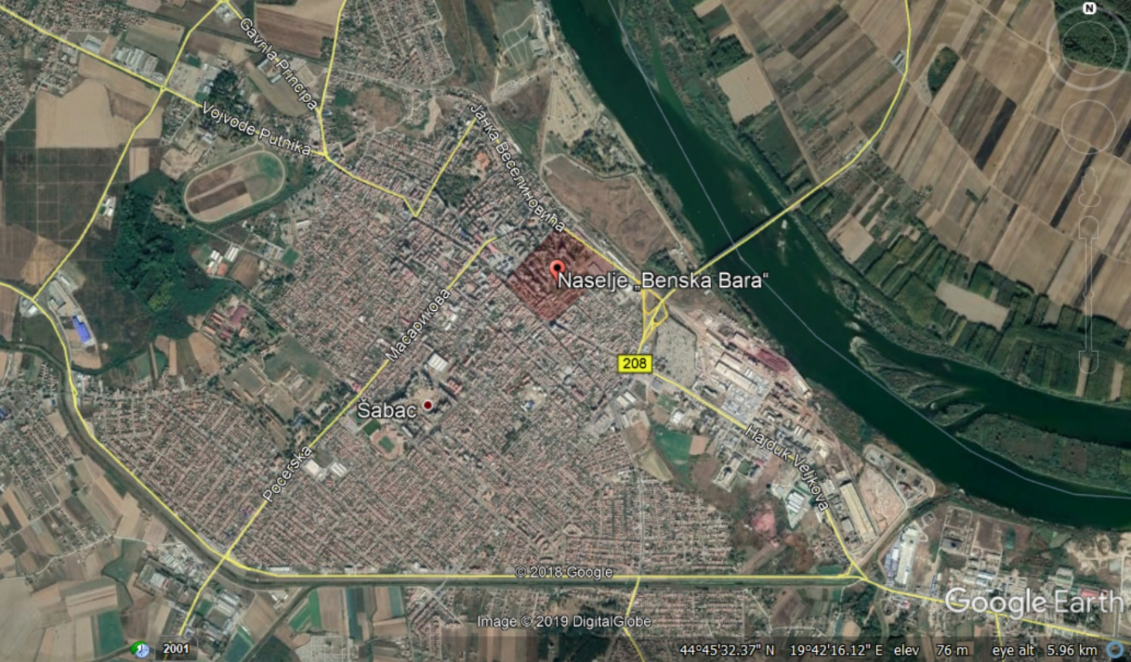
Figure 2-2 - Satellite View B of Benska Bare, Šabac
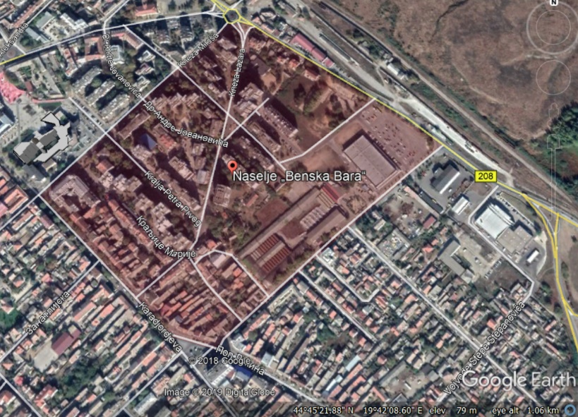
The Benska Bare settlement was designed in accordance with the 1964 General Urban Plan, created by Belgrade architects Uglješ Bogunović and Slobodan Janjić. Previous to this, the area was primarily covered by water – a swampy area fed by the neighbouring Sava River. The settlement now covers almost 20 hectares (19.6 ha).
The flats within the residential buildings provisionally selected for this Project are all privately owned. It is understood that after the breakup of Yugoslavia and the formation of Serbia as an independent country, flats in these multi-storey residential buildings were purchased by the residents in the mid-90s.

Organisational arrangements

Project influence
The table below presents the influence of these stakeholders on this Project:
Table 3-1 – Šabac Residential Buildings Energy Efficiency Project stakeholders
Type | Name | Impact/Influence
Project Shareholders / Internal Stakeholders | Toplana-Šabac (District Heating Company of Šabac) | This group will directly influence and impact the project through the decision-making process. They are considered as ‘Primary Stakeholders’.
Project Implementation Unit (PIU) | PIU Toplana-Šabac | The group of individuals, led by the Project Director who are ultimately responsible for the delivery of this project and compliance the EBRD’s E&S Policy.
Lending Organisation | European Bank for Reconstruction and Development | This organisation will provide the loan to carry out the Project, alongside certain environmental, social and technical requirements.
Permitting bodies, local governmental agencies | City Council of Šabac | This group will have a direct influence/impact on the project through approving permits, enforcing new regulations and rules.
Communities & Businesses | Local businesses and residents (including vulnerable groups i.e. women, pensioners, veterans, and any formal and informal persons and businesses) located in the buildings directly affected by the energy efficiency works within Šabac City. | The communities and businesses within the buildings may be affected due to temporary loss of access to garages and certain entrances/exits.
Building representatives | Elected residents (volunteers) or housing management professionals (paid) managing the utilities with joint accountability of the building. | Disseminate information to the residents of the flats and share decisions of residents to public utilities.
NGOs | At this stage, no NGOs have been active relevant to this project.
Contractors/Suppliers | Contractors and equipment suppliers on the Šabac Residential Buildings Energy Efficiency Project. | This group will directly participate in the implementation of the Project.
Supervising Engineer | EBRD Consultant | Tasked with the supervision of the Contracts execution, they will ensure that all applicable environmental and social requirements of the Bank are being adhered to and that the PIU is informed of the contractor’s performance.

Management Structure and Resource Capacity
Lenders’ Requirements set out expectations with regards to organisation capacity and commitment to adhere to the environmental and social (including health and safety and labour) requirements.
Currently, an Officer of Occupational Safety & Health is the relevant full-time employee of the DH Company (Mrs Gordana Lakčevič) ensuring EHS compliance. To enhance organisational capacity for this project, additional support around the monitoring of E&S aspects will be introduced. This will be conducted during construction by the Supervising Engineer.
The Supervising Engineer consultant will ensure that all applicable environmental and social requirements of the Bank are being adhered to and that the PIU is duly informed about the requirements. This includes providing assistance to PIU in implementation of the Environmental and Social Action Plan (ESAP), ESMP, SEP and preparation of annual environmental and social reports to the Bank using the approved EBRD reporting format.
The Supervising Engineer will also need to supervise and monitor the implementation of the Contractor’s Environmental and Social Management Plan (CESMP), that will be based on this document and will be included under the Contractor’s contractual conditions.

EHSS Management Meetings and Reports
Section 4 provides a detailed breakdown of the required actions of this ESMP, which will be carried out by contractors through their CESMP. However, in order to effectively manage and monitor these tasks, Toplana-Šabac will organise and conduct the following meeting schedule:
- Weekly EHS Management meeting: The Project Director and Officer for Occupational Safety and Health will conduct weekly EHS meetings with the individual responsible for E&S monitoring for the Supervising Engineer (an EHS Committee). If any significant issues have arisen, an EHS representative from the relevant contractor could also be invited to the meeting.
- Weekly Progress Report: The Supervising Engineer will prepare brief Weekly Progress Reports to be presented to the DH Company and discussed at the weekly EHS Committee meetings, including environmental, social and H&S problems that occurred during that week and precautions taken.
- Monthly EHS Monitoring Reports: The Supervising Engineer will prepare these monthly reports, in which EHS performance of the project is evaluated. All negative incidents will be recorded on site.
- Annual Environmental and Social Reports (AESR): As required under the investment contract, Toplana-Šabac must submit this annual report to EBRD. These will be prepared by the Project Director and submitted to the relevant Project Manager in the Bank.
The management meetings should take place as a minimum to monitor the implementation of the Project and the completion of E&S measures defined in the ESAP. The contractor(s) will therefore need to work closely with the Supervising Engineer, providing them with updates on the progress of their E&S measures and provide continued access to their ongoing works.
On top of these meetings, Toplana-Šabac’s Officer for Occupational Safety and Health will inspect the sites on at least a weekly basis, discussing any specific breaches with the Supervising Engineer in order for action to be taken to address these effectively and efficiently.
The SEP also demonstrates that Toplana-Šabac will undertake weekly meetings with the City Council, affected business owners and representatives of the selected buildings. These representatives of the buildings will pass on information (such as the construction schedule) to the residents, as well as voice any of the residents’ concerns to Toplana-Šabac. Limited direct engagement is foreseen between the contractors and the residents of the buildings.

Environmental and SOcial Management Plan
This ESMP is developed to address the issues identified in the ESAP and provide measures and actions to mitigate/ manage adverse impacts, or to enhance positive or beneficial impacts. Designed to provide guidance to the Contractor in developing their CESMP, this ESMP is based on the following mitigation hierarchy:
- Avoidance;
- Minimisation; and
- Compensation/ offset.
Toplana-Šabac is the main responsible party for minimising or eliminating possible environmental and social impacts of the Project. They must allocate financial resources and designate personnel within the organisation to implement the management programme. A procedure to adjust the ESMP and to adapt actions and mitigation based on environmental and social monitoring data must be developed.
It is the ultimate responsibility of Toplana to ensure that the ESMP is being complied with by all organisations involved, including contractors. To guarantee the environmental performance of the Project, all contractors will be made aware of their responsibilities in the construction works and through this ESMP.
The SEP provides a designated system for provision of project information and any complaints from the community. This mechanism handles the following subjects:
- Informing the public about the progress of the project;
- Taking the complaints and recording them; and
- Handling the complaints in a quick and effective manner and resolving them.
In order to mitigate and manage potential environmental and social impacts, this ESMP has been developed to address potential impacts during the construction phase. No adverse E&S impacts are expected during the operational phase. The plan is dynamic and will be reviewed and updated periodically to ensure its continued effectiveness. The decommissioning of these energy efficiency measures is not foreseen. Therefore, a decommissioning plan is not required.

Contractor Requirements
A project-specific CESMP will be prepared by the Contractor prior to the start of construction activities, ensuring that the requirements of the ESMP are implemented by the contractors within their own management procedures.
During the construction phase, the main ESMP responsibilities of the contractors are to:
- Assign a person responsible for HSE to directly liaise with the Supervising Engineer and Toplana-Šabac regarding E&S issues, contributing to the Project’s environmental performance;
- Comply with the E&S actions listed, ensuring compliance through their internal monitoring processes and regular reporting to the Supervising Engineer;
- Train construction staff to raise environmental and social consciousness;
- Fulfil and comply with all the legal requirements of Serbian environmental, social and H&S legislation and EBRD PRs;
- Acquire licenses required in accordance with the Serbian legislation to conduct construction activities (e.g. permitting for safe scaffolding erection, etc); and
- Ensure sub-contractors (if involved) comply with all of the above.
The individual responsible for E&S compliance for the Supervising Engineer will be responsible for inspecting the site, making recommendations for improvements with regard to EHS, analysing the causes of accidents/incidents and making recommendations concerning necessary changes. This individual will also be joined on occasions by the Project Director and Officer for Occupational Safety and Health (the EHS Committee as described in section 3.3).
With the monitoring results documented by the Supervising Engineer, the effectiveness of the mitigation of impacts will be discussed by the EHS Committee. Necessary additional corrective and preventive action (if required) will be identified by the Committee, and subsequently this ESMP will be adjusted accordingly. Any alterations made to this document will be shared with the contractors so their CESMP can be amended to align to these new revisions to the ESMP, if required.
The E&S mitigation measures to be carried out by the Contractor prior to and during the construction phase is presented in the table below:

Table 4-1 – Contractor’s E&S actions for before and during construction for the Šabac Residential Buildings Energy Efficiency Project
No | Activity | EHS risks / impacts | Compliance Requirement | Mitigation Description | Implementation Period |  | Monitoring / Verification
 |  |  |  |  | Period | Deadline | Responsibility | Measures
- General
1.1 | Develop a CESMP in-line with the contract documentation. | Ensuring legal compliance and cascading all E&S construction issues to the Contractor. | EBRD PR1 | ESMP developed by EBRD to be used as the basis of this document. | Prior to the start of works, immediately after contract signing. | Fully agreed before construction begins. | Toplana-Šabac PIU | CESMP to be approved by the PIU before construction begins.
1.2 | Ensure suitable experience, qualifications ad competency in E&S within the Contractor’s team. | E&S issues are not reported resulting in non-compliance. | EBRD PR1 | Terms of Reference for the Contractor will stipulate the requirement of an individual responsible for E&S aspects being employed by the Contractor on this project through the contractor works.  Responsible individual will have previous experience in developing and implementing CESMPs. | Evidence of proposed candidate experience, competency and qualifications provided in tender proposal. | Proposal submission deadline. | Toplana-Šabac PIU | Review suitability of responsible individual in proposal documentation.
1.3 | Contractor’s/ supplier’s contractual terms | Contractor’s EHS compliance, labour and working conditions, HR policy and procedures, Code of Conduct, community safety and security, supply chain sustainability, grievances | Serbian legal requirements, EBRD PR1, EBRD PR2 | All contractors and supply chain members shall comply with Serbian, EBRD and ILO standards. | Contractor negotiation and appointment. | Signing of contract with Toplana-Šabac. | Toplana-Šabac PIU | Tender dossiers to contain all requirements and will be retained by the PIU.
1.4 | Sub-contractor contractual terms | Sub-contractor competency/ credentials. | EBRD PR1, EBRD PR2 | Lead contractors to provide sub-contractors and supply chain credentials as part of their tender submission.  If sub-contractors are changed, competency information should be provided by the lead contractor to the PIU for review and approval. | Contractor negotiation and appointment. | Signing of contract with main Contractor. | Toplana-Šabac PIU | Review of contractor tender dossiers.
1.5 | Supervising Engineer (SE) monitoring of the Contractor | Ensuring that the Contractor’s CESMP (and in extension this ESMP) is being adhered to by the Contractor. | EBRD PR1 | Regular monitoring will be undertaken by the SE to ensure that the contractor(s) are complying with the ESMP.  Contractors will provide SE with weekly information on status of their planned and ongoing E&S mitigation measures.  This will be supported by site inspections and a review of procedures to ensure that the CESMP is still relevant and fit for purpose. This monitoring will feed into the SE’s weekly meetings with Toplana-Šabac and the Monthly EHS Reports. | Prior to and during contractor works (throughout the duration of the Supervising Engineer’s services). | End of works | Toplana-Šabac PIU | Meetings of EHS Committee.
- Site Management
2.1 | Roles and responsibilities | Ensuring legal compliance | EBRD PR1 | ESMP will be presented to all contractors as part of any tender documents to make them aware of their responsibilities and the actions that they must incorporate into their site activities. | Contractor negotiation and appointment. | Signing of contract with Toplana-Šabac. | Toplana-Šabac PIU | Tender dossiers to contain all requirements and will be retained by the PIU.
2.2 | Construction works | ESMP management | EBRD PR1, EBRD PR3 | All contractors will present Supervising Engineer with their method statements and procedures (as part of their CESMP) for review and sign off. | Pre-construction | Fully agreed before construction begins. | Supervising Engineer | Review and retain methods statements and procedures received.
- Environment
3.1 | Source of construction materials | Supply chain non-compliance | EBRD PR3 | Contractor to use construction materials sourced only from authorised sites, where practical. | Prior to and during construction. | Ongoing for contractor works. | Contractor and Supervising Engineer | Review of supplier agreements.
3.2 | Segregation of hazardous waste | Inappropriate hazardous waste disposal and waste acceptance | EBRD PR3 | Develop procedure for segregation of hazardous waste, such as asbestos-containing materials (ACMs), during collection. Follow the guidance put forward in Toplana-Šabac’s ACM survey report.  Develop waste acceptance procedure. The procedure shall also consider the temporary storage of the hazardous waste identified through the acceptance procedure implemented at the site and its safe transport from the building.  CESMP should also follow the processes of Toplana-Šabac’s existing Waste Management Plan. | Prior to and during construction. | Ongoing for contractor works duration. | Contractor and Supervising Engineer | Review of contractor processes and ongoing onsite monitoring.
3.3 | Energy efficiency | Inefficient energy use | EBRD PR3 | Energy efficiency requirements will be included in the tender specifications for the Contractor, with practises stated in the CESMP.  These requirements will include ensuring equipment and vehicles are maintained based on their specifications, and turning off equipment and vehicles when not in use.  The contractor will also ensure that the materials purchased and used are energy efficient. | Developed prior to construction. | Measures ongoing for contractor works duration. | Contractor and Supervising Engineer | Review of contractor processes and ongoing onsite monitoring.
3.4 | Access during construction | Resident, business and pedestrian disturbance and accidents/ incidents | EBRD PR4, PR5 | CESMP to include measures to ensure access is continued to residents and business owners. Workers should also be suitably segregated from pedestrians. | Developed prior to construction. | Measures ongoing for contractor works duration. | Contractor and Supervising Engineer | Review of contractor processes and ongoing onsite monitoring.
3.5 | Water use during construction works | Water efficiency | EBRD PR3 | Develop and implement water saving efficiency measures, with practises stated in the CESMP. | Developed prior to construction. | Measures ongoing for contractor works duration. | Contractor and Supervising Engineer | Review of contractor processes and ongoing onsite monitoring.
Health and Safety
3.6 | Construction works | Occupational health and safety | EBRD PR2 | Contractor to develop Project-specific OHS policy and practices for the workforce covering job and task specific PPE and other requirements. The OHS policy will contain enforcement measures that will also be publicised with workers.  This OHS policy will include safety measures when working at height. The Contractor should follow a formal permit to work system for working at height/hot work. This will include the provision of the ladder systems, scaffolding and man safe systems for working at height is in line with good international practice. | Developed prior to construction. | Measures ongoing for contractor works duration. | Contractor and Supervising Engineer | Tender dossier, review of contractor processes and ongoing onsite monitoring.
 |  |  |  | Carry out and keep updated OHS risk assessment of work places, reviewed by Supervising Engineer.
 |  |  |  | Contractor to liaise with Supervising Engineer to conduct training sessions for the workers where OHS policies, procedures and practices are explained.
 |  |  |  | Develop an emergency preparedness and response plan to cover both occupants and the Contractor’s workers during the works (include consideration of natural hazards such as earthquake, flood and extreme weather scenarios).
3.7 | Community health, safety and security | Inadequate protection provided to the local community’s health, safety and security. | EBRD PR4 | As part of the CESMP, identify mitigation measures to construction nuisances including noise, dust, vibration, community health, safety and security and develop and adopt the relevant management plans to mitigate these impacts. | Developed prior to construction. | Measures ongoing for contractor works duration. | Contractor and Supervising Engineer | Review of contractor processes and ongoing onsite monitoring.
 |  |  |  | The following mitigation procedures, relevant to community H&S, should be included in the CESMP by the COntractor: provision of road signs during the construction stage; sufficient notice to communities (including women) about the construction work; develop specific routes to ensure community right of way is not affected; considerations of avoiding pedestrians whilst working; minimise disruption to road traffic and emergency rsponse.
 |  |  |  | CESMP must provide measures to ensure that the scaffolding installed does not block entrances/exits to the buildings, fire exits remain open (or temporary routes defined), business entrances remain open and accessible, and disability access is not impaired.
3.8 | Fire Safety Report | Ensuring fire safety of materials and installation of thermal insulation measures. | EBRD PR4 | The design engineer will submit a full fire safety report for Project before construction; this will be thoroughly reviewed by a fire engineering specialist.  Contractor will ensure that correct installation measures are followed, following the advice of the fire safety report. | Installation method statement agreed prior to construction. | Measures ongoing for contractor works duration | Supervising Engineer | Review of contractor processes and ongoing onsite monitoring.
Social
3.9 | Consultation, information disclosure and grievance mechanism | Inadequate consultation and stakeholder engagement | EBRD PR10 | Toplana-Šabac to conduct most SEP activities. Contractor will share their works schedule with Toplana-Šabac to inform the public of the timings of any potential nuisances and ongoing mitigation measures. | Developed prior to construction. | Measures ongoing for contractor works duration. | Supervising Engineer | Review of contractor processes and ongoing onsite monitoring.
 |  |  |  | Contractor workers also made aware of the grievance mechanism, and know how to escalate grievances to the Supervising Engineer.
 |  |  |  | Contractor workers knowledgeable of and able to access the grievance mechanism.
3.10 | Labour and working conditions planning | Exploitation of workers’ rights | EBRD PR2 | Contractor to develop a Project-specific HR Policy, procedures and practices. Establish equal opportunities and non-discrimination policies and engage local labour force, both men and women equally in different Project aspects. | Developed prior to construction. | Measures ongoing for contractor works duration. | Contractor and Supervising Engineer | Review of contractor processes and ongoing onsite monitoring.
 |  |  |  | HR Policy of the contractor will ensure that those working at height and doing hot work are suitably qualified for such tasks.
 |  |  |  | Develop a workers Code of Conduct and procedures to audit the Project supply chain.

8 First Street
Manchester
M15 4RP

wsp.com

The client will establish, maintain, and strengthen, as necessary, an organisational structure that defines roles, responsibilities, and authority to implement the ESMS for ensuring on-going compliance with relevant national regulatory requirements, and the PRs. The client will designate specific personnel, including management representative(s), with clear lines of responsibility and authority to maintain and implement the ESMS. Key environmental and social responsibilities will be defined and communicated to the relevant personnel. The client will provide adequate support and human and financial resources on an on-going basis to achieve effective and continuous environmental and social performance; (EBRD, 2014).

